INTRODUCTION
What is Lorem Ipsum?
Lorem Ipsum is simply dummy text of the printing and typesetting industry. Lorem Ipsum has been the industry's standard dummy text ever since the 1500s, when an unknown printer took a galley of type and scrambled it to make a type specimen book. It has survived not only five centuries, but also the leap into electronic typesetting, remaining essentially unchanged. It was popularised in the 1960s with the release of Letraset sheets containing Lorem Ipsum passages, and more recently with desktop publishing software like Aldus PageMaker including versions of Lorem Ipsum.
Why do we use it?
It is a long established fact that a reader will be distracted by the readable content of a page when looking at its layout. The point of using Lorem Ipsum is that it has a more-or-less normal distribution of letters, as opposed to using 'Content here, content here', making it look like readable English. Many desktop publishing packages and web page editors now use Lorem Ipsum as their default model text, and a search for 'lorem ipsum' will uncover many web sites still in their infancy. Various versions have evolved over the years, sometimes by accident, sometimes on purpose (injected humour and the like).
Where does it come from?
Contrary to popular belief, Lorem Ipsum is not simply random text. It has roots in a piece of classical Latin literature from 45 BC, making it over 2000 years old. Richard McClintock, a Latin professor at Hampden-Sydney College in Virginia, looked up one of the more obscure Latin words, consectetur, from a Lorem Ipsum passage, and going through the cites of the word in classical literature, discovered the undoubtable source. Lorem Ipsum comes from sections 1.10.32 and 1.10.33 of "de Finibus Bonorum et Malorum" (The Extremes of Good and Evil) by Cicero, written in 45 BC. This book is a treatise on the theory of ethics, very popular during the Renaissance. The first line of Lorem Ipsum, "Lorem ipsum dolor sit amet..", comes from a line in section 1.10.32.
The standard chunk of Lorem Ipsum used since the 1500s is reproduced below for those interested. Sections 1.10.32 and 1.10.33 from "de Finibus Bonorum et Malorum" by Cicero are also reproduced in their exact original form, accompanied by English versions from the 1914 translation by H. Rackham.

Where can I get some?
There are many variations of passages of Lorem Ipsum available, but the majority have suffered alteration in some form, by injected humour, or randomised words which don't look even slightly believable. If you are going to use a passage of Lorem Ipsum, you need to be sure there isn't anything embarrassing hidden in the middle of text. All the Lorem Ipsum generators on the Internet tend to repeat predefined chunks as necessary, making this the first true generator on the Internet. It uses a dictionary of over 200 Latin words, combined with a handful of model sentence structures, to generate Lorem Ipsum which looks reasonable. The generated Lorem Ipsum is therefore always free from repetition, injected humour, or non-characteristic words etc

Paragraph Spacing should be 1.15

    - Paper size :A4 (210 x 297 mm)
    - Margins : Left : 3.81cms (1.5”); Other margins: 2.54cms (1”)
    - Font type :Times New Roman/Arial/Tahoma
    - Font size (main text) : 12 (not in bold)
    - Font size (notes/foot notes) :10 (not in bold) etc.
    - Font size (titles) :14 Bold
    - Font size (subtitles) :12 Bold
    - Line spacing (main text) :1.15
    - Line spacing quotations for :1
AIMS AND OBJECTIVES

Primary Objective:

Secondary Objective:

BACKGROUND AND REVIEW OF LITERATURE
The standard chunk of Lorem Ipsum used since the 1500s is reproduced below for those interested. Sections 1.10.32 and 1.10.33 from "de Finibus Bonorum et Malorum" by Cicero are also reproduced in their exact original form, accompanied by English versions from the 1914 translation by H. Rackham.

RELEVANCE
The standard chunk of Lorem Ipsum used since the 1500s is reproduced below for those interested. Sections 1.10.32 and 1.10.33 from "de Finibus Bonorum et Malorum" by Cicero are also reproduced in their exact original form, accompanied by English versions from the 1914 translation by H. Rackham.

.

METHODOLOGY
STUDY DESIGN:
Cross sectional study with comparison.
STUDY SETTING:

STUDY DURATION:
One year, from January 2023 to January 2024, after getting approval from the Human Ethics Committee, Government Medical College, Thiruvananthapuram.
SAMPLE SIZE:
Based on a study done by …………….. sample size required for this study is calculated as follows⁹⁵: -
Formula for calculating Sample size:
n= $\frac{2S_{p}^{2} {(z_{1-α/2}+z_{1-β})}^{2}}{µ_{δ}^{2}}$
where $s_{p}$² = $\frac{s_{1}^{2}+s_{2}^{2}}{2}$
• (𝑧₁−_{∝/2} +𝑧₁−_{𝛽})² when β = 0.2 (80% power) = 7.849
m1 = 5.58, m2= 0.97, s1 = 6.50, s2 = 1.79
The sample size is taken as: -
n = 30; for study group
n = 30; for comparison group

STUDY POPULATION:

Inclusion criteria
Exclusion criteria
ETHICS COMMITTEE CLEARANCE:
SAMPLING METHOD:
DATA COLLECTION:

RESULTS

DISCUSSION
.

LIMITATIONS OF THE STUDY
- .

FUTURE PERSPECTIVES
- .

CONCLUSION

REFERENCES
1. Lotfy AWM, Mohammed NA, El-Tokhy HM, Attia FA. Serum visfatin in chronic renal failure patients on maintenance hemodialysis: a correlation study. Egypt J Intern Med. 2013 Dec;25(4):202–8.

References in Vancouver Style

ANNEXURES
ANNEXURE 1: PROFORMA
Name:
Age:
Sex:
OP/IP number:
Address:
Occupation:

General Examination:
Systemic Examination:

ANNEXURE 2
PATIENT INFORMATION SHEET

Post graduate student
Department of Biochemistry
Government Medical College,
Trivandrum

PATIENT CONSENT FORM

രോഗി അറിയേണ്ടതായ വിവരങ്ങൾ

രോഗിയുടെ സമ്മതപത്രം

ANNEXURE 3: MASTER CHART FOR CASES
Sl No. | AGE (years) | GENDER | BMI (kg/m²) | ESRD | HTN | DM | UREA (mg/dl) | CREATININE (mg/dl) | eGFR (ml/min/1.73m²) | TC (mg/dl) | TGL (mg/dl) | HDL (mg/dl) | VLDL (mg/dl) | LDL (mg/dl) | VISFATIN (ng/ml)

MASTERCHART FOR CONTROLS
Sl No. | AGE  (years) | GENDER | BMI  (kg/m²) | UREA  (mg/dl) | CREATININE  (mg/dl) | eGFR  (ml/min/1.73m²) | VISFATIN  (ng/ml)

ANNEXURE 4
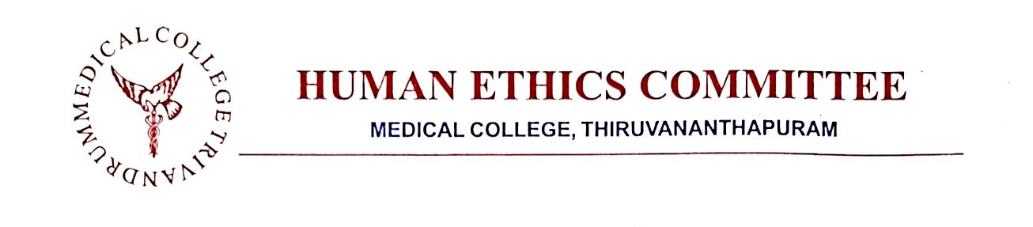

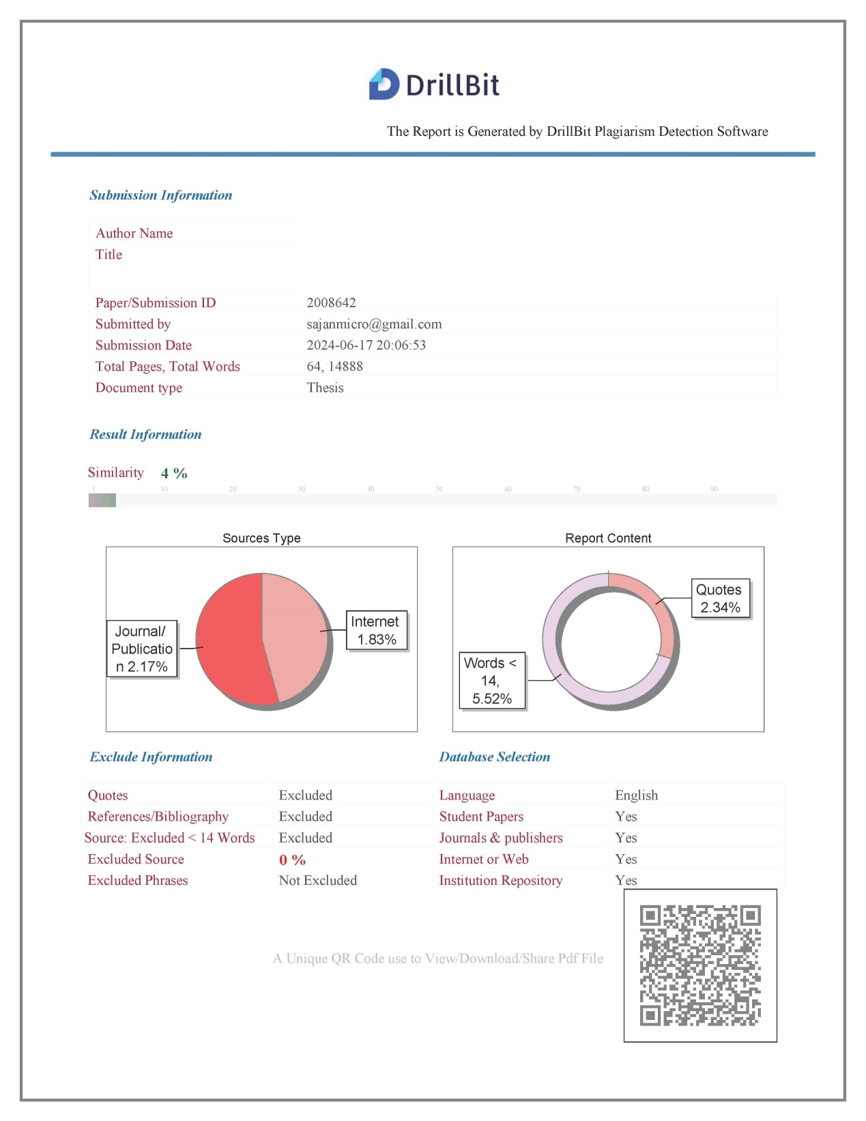

ANNEXURE 5

Plagiarism Verification – certificate

Part A

Plagiarism Verification – Certificate

Part A

1. Name of Researcher:

2. Title of the Thesis:

3. Course:

4. KUHS Reg. no

5. Name of Guide/Supervisor:

6. Official Designation of the Guide & Address
The above thesis/ dissertation was scanned for similarity detection.
The report is as follows:
Software used | Drillbit |  |  | Date
Similarity Index |  |  |  | Total word count

The report is attached for the review by the Supervisor
 |  |  | Signature of the Researcher
Name of the Researcher
Address of the Researcher

Part B
The plagiarism report of the above thesis/ dissertation has been reviewed by the undersigned

The similarity index is below accepted norms.

Certified that the thesis/dissertation is plagiarism free/ the similarity content is within the acceptable limits and does not affect the originality of research work. Therefore, the thesis may be considered for submission to the University. The software report is attached.

Signature of the Researcher Signature of the Guide with seal

Name of the Researcher Name and designation of the Guide
Address :

